Chapter Quiz

1. Complete the function table at the right.

Use words and symbols to describe the value of each term as a function of its position. Then find the twelfth term in each sequence.

2.
Position | 1 | 2 | 3 | 4 | n
Value of Term | 3 | 6 | 9 | 12

Position | 5 | 6 | 7 | 8 | n
Value of Term | 0 | 1 | 2 | 3

3.

Write an equation to represent the function.

4. 5.
Input, x | 0 | 1 | 2 | 3
Output, y | 0 | 12 | 24 | 36

Input, x | 1 | 2 | 3 | 4
Output, y | 4 | 8 | 12 | 16

Use the following information for Exercises 6-9.

SPORTS In a football game, each team earns 6 points for each touchdown it scores.

6. Write an equation to find y, the total number of points for scoring touch downs.

7. Make a table to show the relationship between the number of touchdowns scored x and the total points y for 1, 2, and 3 touchdowns.

8. Graph the ordered pairs (x, y).

9. How many points will a team earn if they score 7 touchdowns?

1.
Input, x | x – 4 | Output, y
4
6
8

2. ___________________

3. ___________________

4. ___________________

5. ___________________

6. ___________________

7. ___________________
Touchdowns, x
Points, y

8. ___________________
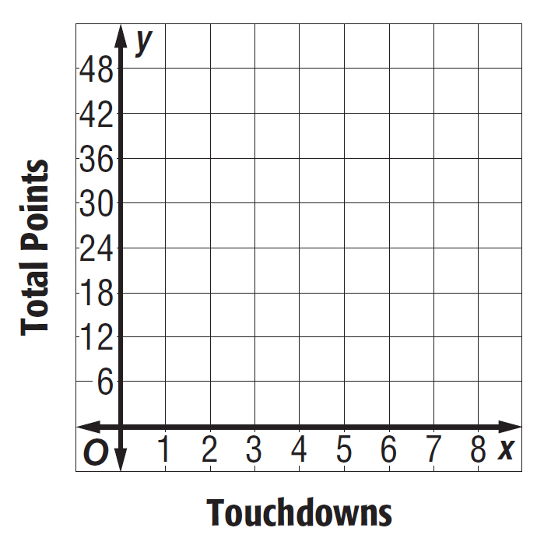

9. ___________________

